How to use DS-K1T201A to connect to
DS-K1109 card reader

Preparation
Type | Model | Version
Software | IVMS-4200 or HCP or HCAC
Access Control Terminal | DS-K1T201AMF
Card reader | DS-K1109DKFB

How to use DS-K1T201A to connect to DS-K1109 card reader

Introduction: This article will introduce how to use DS-K1T201A to connect to DS-K1109 card reader.
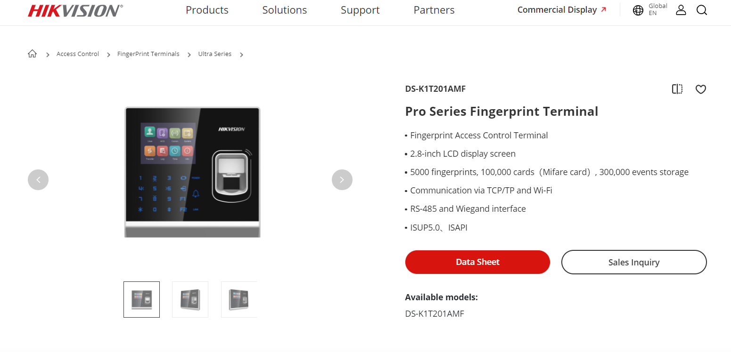
- Wiring
Use RS-485 cable of K1T201A terminal connect to K1109 card reader.
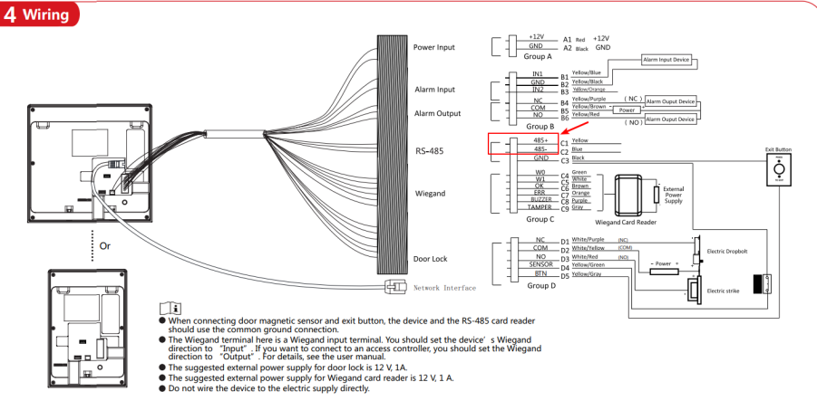

- Configuration
- Add K1T201A to platform.
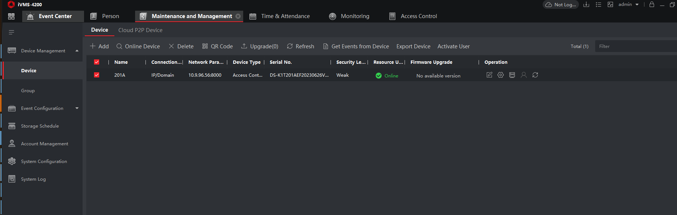
- Enter the device remote configuration page, check the connection mode of RS-485.
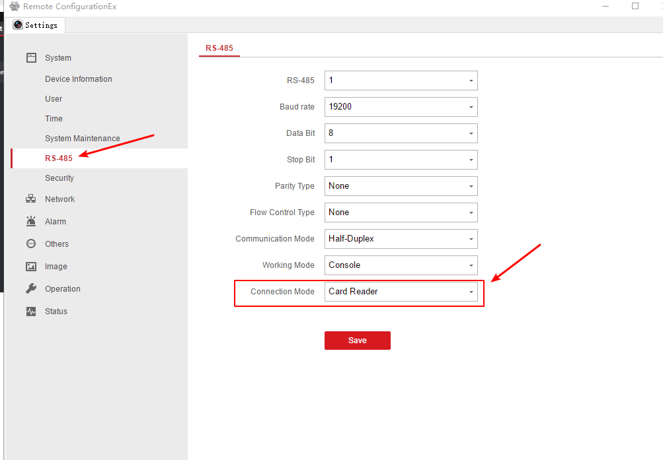

- Configure dip switch of card reader, make sure the dip switch is 0100 0000.
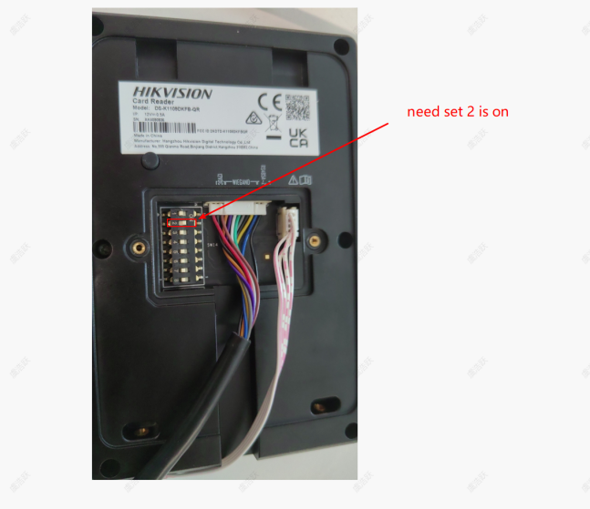
- And then restart the card reader, you can check the exit card reader is online on the door of K1T201A.
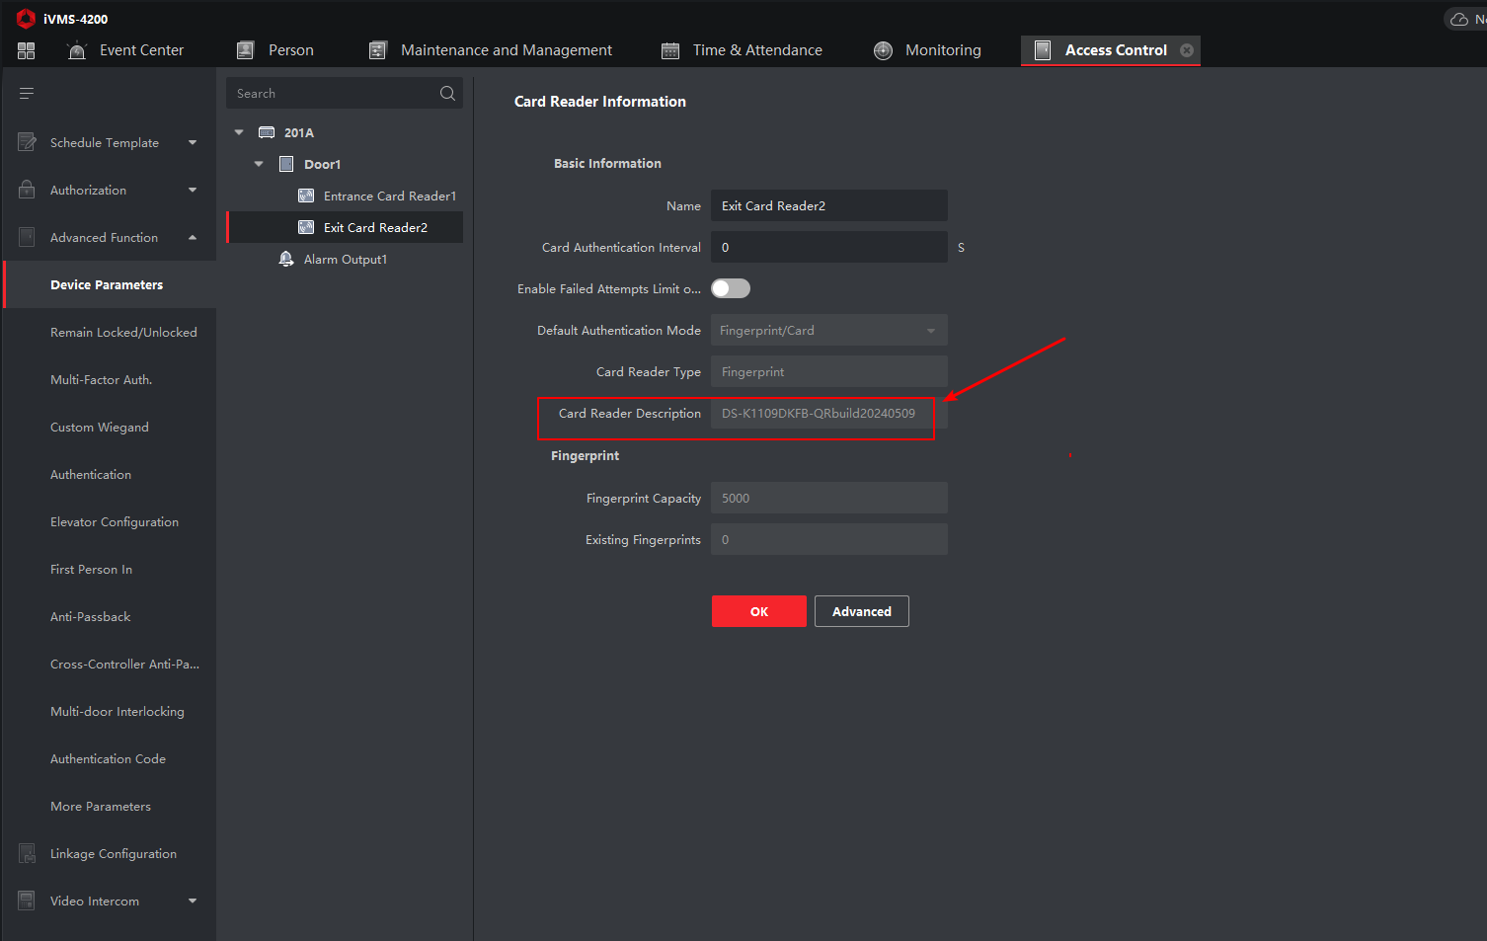
- Test
You can check the swipe card records on Event Center, test result as shown below.
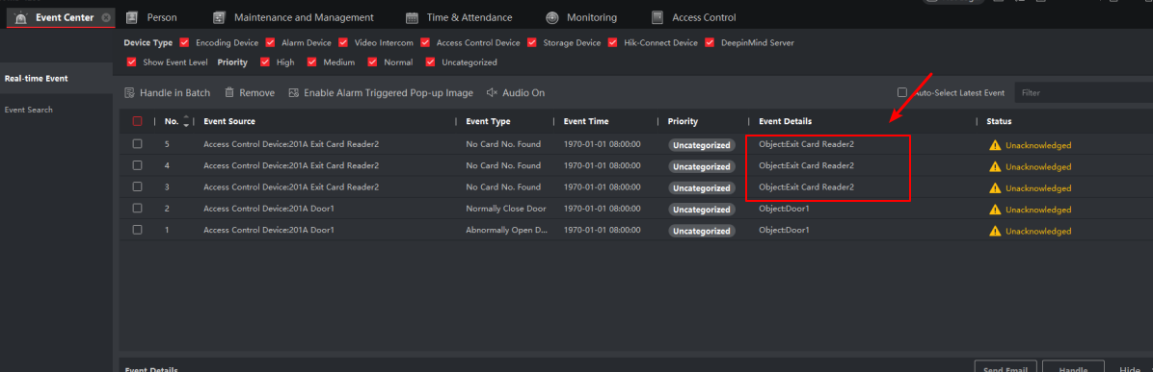
Note:
- Check the K1T201A version, make sure use the latest firmware.
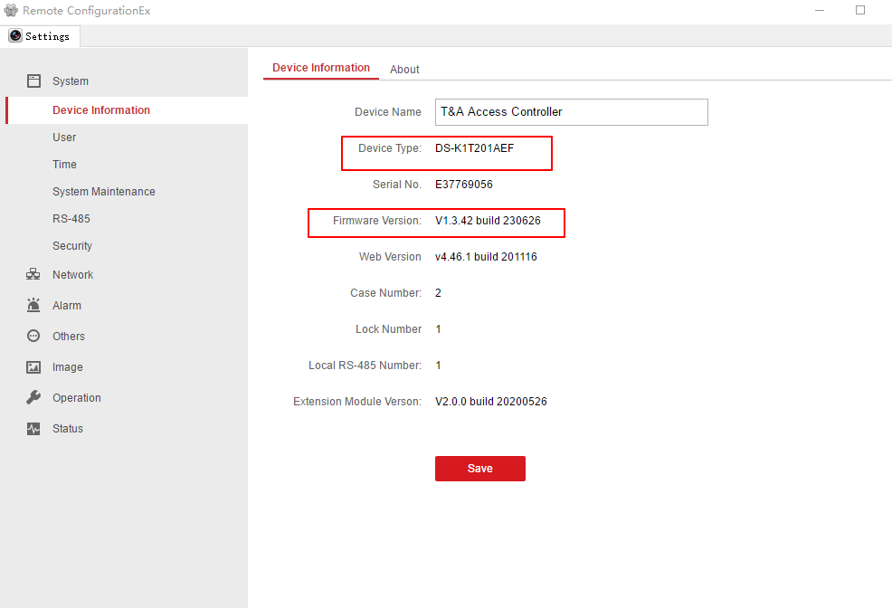
- Check card reader DS-K1109DKFB version, make sure use the latest firmware.
